Hobbies-page 1
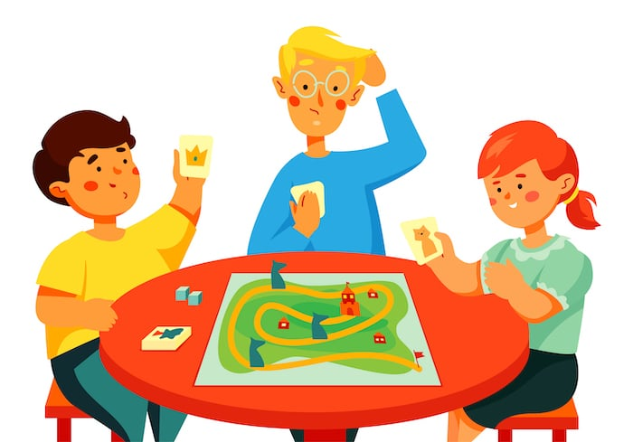 | playing board games

Hobbies-page 2
 | cooking

Hobbies-page 3
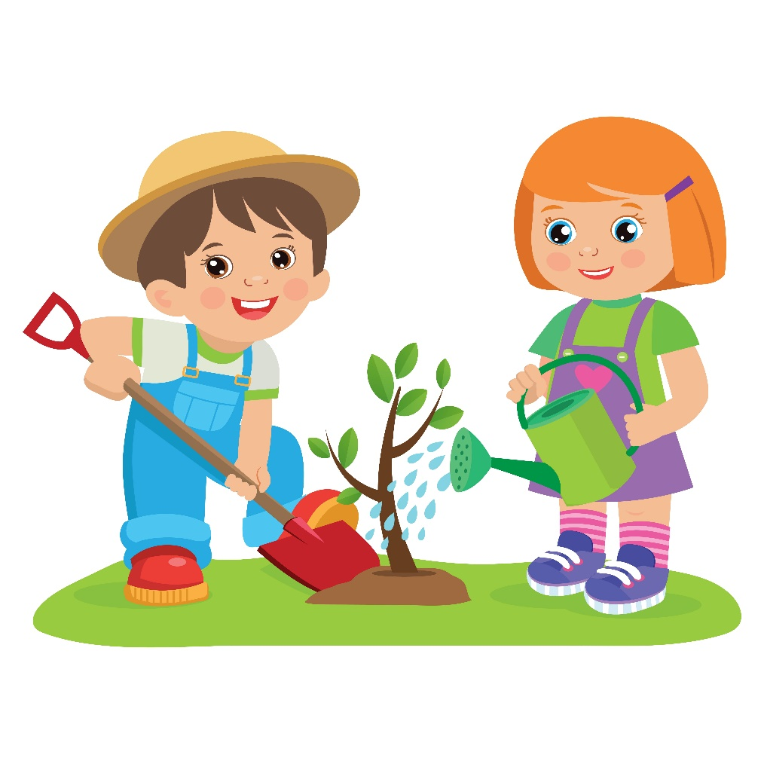 | gardening

Hobbies-page 4
 | reading

Hobbies-page 5
 | listening to music

Hobbies-page 6
 | dancing

Hobbies-page 7
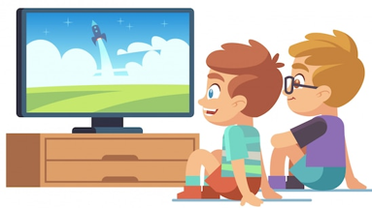 | watching TV

Hobbies-page 8
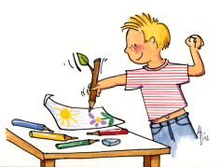 | drawing

Hobbies-page 9
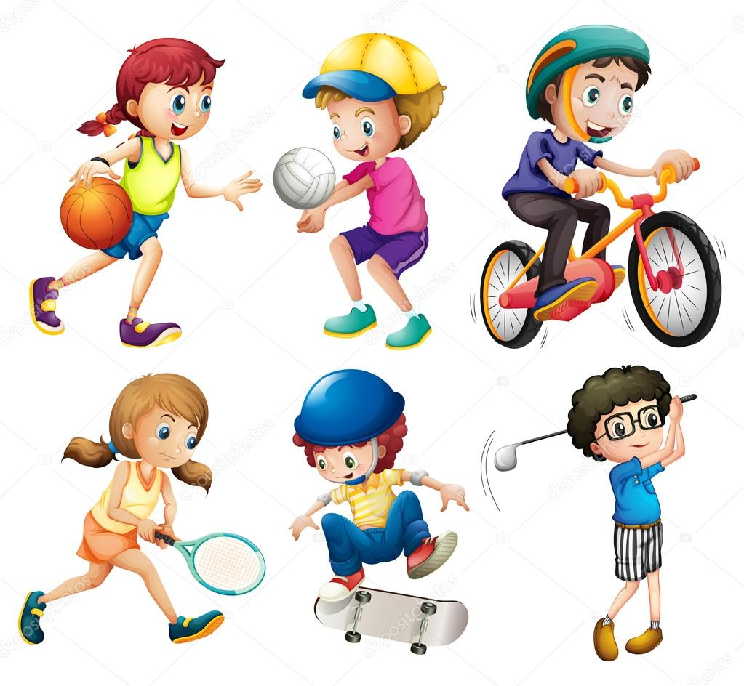 | playing sport

Hobbies-page 10
 | singing

Hobbies-page 11
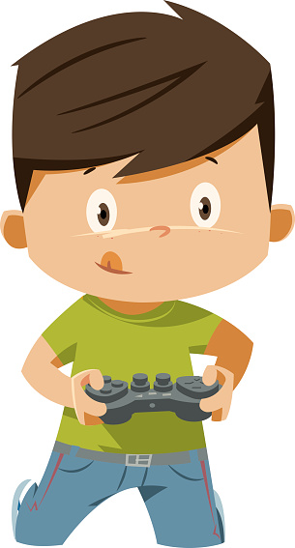 | playing video games

Hobbies-page 12
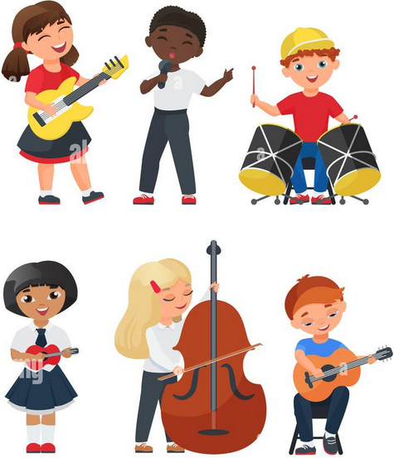 | playing music

