Hobbies – Game 1

1 | 2 | 3 | 4 | 5 | 6
7 | 8 | 9 | 10 | 11 | 12

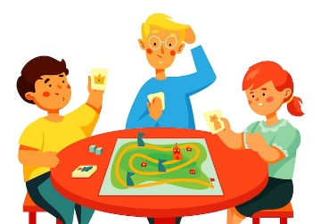 | 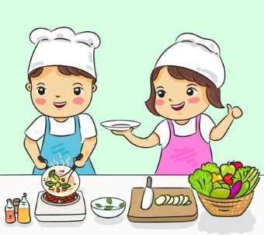 |  |  |  | 
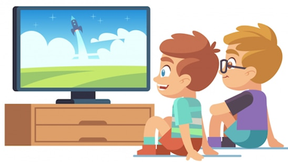 | 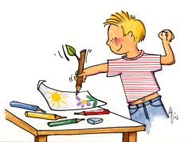 | 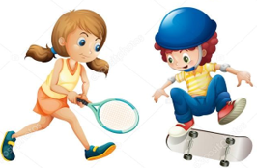 |  |  | 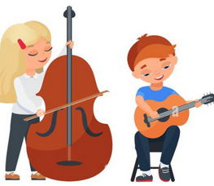

Hobbies – Game 2

1 | 2 | 3 | 4 | 5 | 6
7 | 8 | 9 | 10 | 11 | 12

playing  board games | cooking | gardening | reading | listening  to music | dancing
watching TV | drawing | playing sport | singing | playing  video games | playing music

Hobbies – Game 2

playing  board games | cooking | gardening | reading | listening  to music | dancing
watching TV | drawing | playing sport | singing | playing  video games | playing music

